SAVE ANIMALS , SAVE FUTURE PRETEST ANALYSIS
ISTANBUL BASAKSEHIR TOKI TURGUT OZAL IMAM HATIP SECONDARY SCHOOL
QUESTION 1 : Do you love animals ? 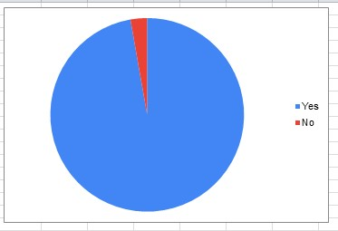
QUESTION 2 : Do you feed street animals ?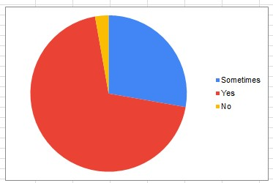

QUESTION 3: Which activities excite you most ?
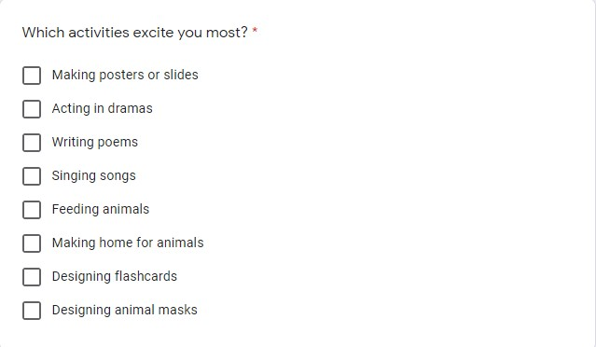
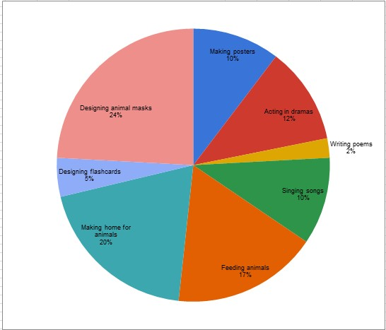
QUESTION 4: Which animals do you like most?
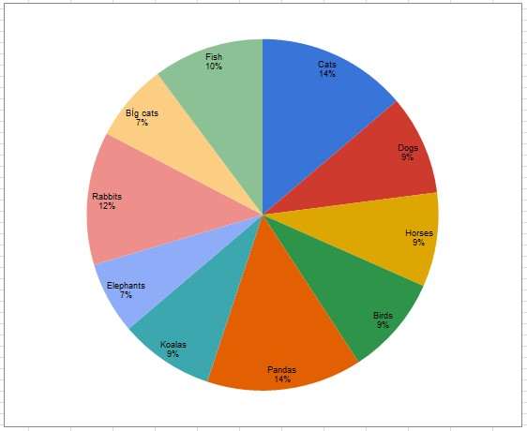
QUESTION 5: Do you have a pet ?
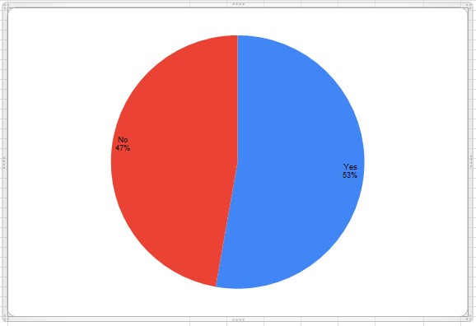

QUESTION 6: How do you feel about taking part in this project?
They all said that they feel happy and excited

